Signsnwraps — PPF & Wrap Kits Website Structure
Oct 13, 2026 · @Arsh

Summary
The site splits into two worlds behind one header switch: SIGNS (signage + print, consultation-led) and WRAPS (vehicle wraps, studio PPF, DIY pre-cut kits and installers). Pre-cut kits are sold inside Wraps, every kit made from AusPPF film. Bushwrapz proves the kit model: a make/model kit finder, DIY vs pro tiers, and an installer network.
We win where Bushwrapz can't: a real studio in Laverton North. Every kit page offers three paths — DIY kit, we fit it in-store, or a certified installer near you — and the consultation CTA stays the brand's primary action.
AusPPF shows as the film inside the kit ("Made with AusPPF film"), not as a second shop. Roll and trade buyers go to ausppf.com.au; kit buyers stay on Signsnwraps.

Site switch: Signs | Wraps
A two-way toggle sits in the header on every page; flipping it swaps the nav, hero, imagery and primary CTA. Each side has its own URL tree (/signs, /wraps) so Google indexes both and links can open straight into one side.
 | SIGNS | WRAPS
Who | Businesses: shopfronts, offices, sites, events | Vehicle owners, fleets, 4WD/ute owners, installers
Nav | Signage · Shopfronts · Printing · Neon · Projects | Vehicle Wraps · PPF · DIY Kits · Find an Installer
Hero | "MAKE YOUR BRAND STAND OUT." + project photography | "BUILT TO STAND OUT. WRAPPED TO PROTECT." + kit finder
Primary CTA | Book a Signage Consultation | Find my kit · Book a Wrap/PPF Consultation
Buying | Quote-led: consult → proposal → install | Cart for kits; booking for studio wraps/PPF
Extras | Case studies, sign types, materials guide | Installer map, install guides, AusPPF film specs, cart
Specialist brands | Quick Signage, QuickNeons, BannerGuru | AusPPF, Signsnwraps Vehicle Studio
Switch rules:
- Home (/) opens as a split screen — two halves, Signs and Wraps — and the visitor picks; returning visitors land on the side they used last
- Ads and SEO pages link straight to /signs/... or /wraps/..., skipping the split
- The switch keeps the same brand: black + electric blue on both sides; Wraps can use darker, automotive photography, Signs brighter storefront shots
- Cart icon shows only on the Wraps side; the consultation button shows on both, labelled for that side
- Contact, About, Laverton North studio and footer are shared

What Bushwrapz does
Bushwrapz is a Brendale QLD brand selling pre-cut PPF kits for 4WDs, sold DIY or fitted by an accredited installer network (home, compare films, become an installer). Its whole site funnels into one action: pick your make and model.
Element | How Bushwrapz does it | Our move
Kit finder | Make → model dropdown in the hero and again mid-page; ~20 brands | Copy. Add body type (car, ute, 4WD, SUV) so we aren't 4WD-only
Product tiers | CAPE (DIY, 1 yr), Advance (DIY, 5 yr), PRO (installer only, 10 yr), HD (8.5 mil, installer only, 12 yr) | Fewer, clearer tiers: DIY kit · Studio-fitted · Installer-fitted
DIY vs pro | Tabs + comparison table; DIY stops 3–5 mm short of edges, pro gets wrapped edges | Same honesty, plus a third path: fitted at our Laverton North studio
Range | 4WD, caravan, marine, universal, bike, replacement panels, rolls, tools, offcuts | Launch with cars/utes/4WD, panels, universal, tools; add caravan/marine later
Colour | Clear first; black, tinted headlight, sunroof films as extras | Lead with colour PPF from AusPPF — Bushwrapz is weak here
Installer network | 40–60+ installers (site gives both figures), accreditation courses, leads pushed to dealers | Signsnwraps Installer Program, phased in after the studio proves the kits
Trust | Testimonials, warranty tiers, install videos, "Number 1" claim | Real studio, before/after photos, video guides, AusPPF film specs
Pricing | Not shown on the homepage | Show kit prices on product pages — e-commerce needs it
Weak spots to exploit: no physical showroom experience, 4WD-only identity, inconsistent installer numbers, and a placeholder-text block left on the installer page.

AusPPF's role
AusPPF is the film brand; Signsnwraps is the retail kit brand built on it. AusPPF sells clear PPF and 24 colour PPF finishes by the roll, enquiry-only, no published pricing, aimed at trade installers. Headlight and window film are listed as coming.
 | AusPPF | Signsnwraps Kits
Sells | Film rolls | Pre-cut kits + fitting
Buyer | Installers, detailers, wrap shops | Vehicle owners, fleets, installers
Buying | Enquiry → quote | Online cart with prices, or book a fitting
Pricing | Not published | Published per kit
How it shows on Signsnwraps:
- A "Made with AusPPF film" badge on every kit and a Film page with specs (7.5 mil, self-healing, anti-yellowing, gloss, stain resistance)
- Colour PPF swatches pulled from the AusPPF range, sold as kits
- A small "Buying film by the roll? Visit AusPPF" link in the footer and on the trade page, so roll buyers leave and kit buyers don't
- The upstream manufacturer stays off both sites

Positioning
Kits live on the WRAPS side, beside vehicle wraps and studio PPF, so a kit is a door into the studio, not a rival to it. Positioning line: "Pre-cut protection. Fit it yourself, or let us fit it."
Path | Who it's for | What they get | CTA
DIY Kit | Budget-minded owners, 4WD and ute owners who like to tinker | Pre-cut kit, tools, video guide; stops a few mm short of edges | Add to cart
Studio-fitted | Melbourne/Geelong owners wanting a finished job | Kit fitted at Laverton North with wrapped edges where possible | Book an In-Store Consultation
Installer-fitted | Owners outside Melbourne | Kit shipped to a certified installer near them | Find an installer
Trade | Detailers, wrap shops | Kits at trade price; film rolls via AusPPF | Apply for trade
Rules that keep it on-brand:
- Same black/electric-blue system; kits are not a separate brand
- "Book an In-Store Consultation" stays the primary CTA site-wide; on kit pages, "Add to cart" sits beside it
- Speak like the expert: tell people which path suits their vehicle and driving, not just what's cheapest

Sitemap
Header on every page: logo · [SIGNS | WRAPS] switch · side nav · consultation button (+ cart on Wraps). The tables below are the Wraps side; Signs keeps the signage pages from the brand book's Signs and Print pillars under /signs.
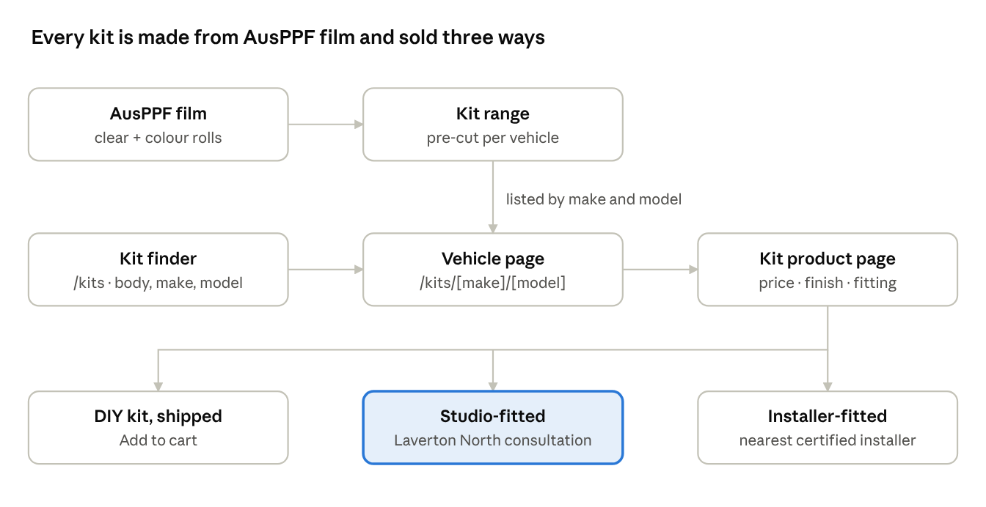
kit flow · film to fitting, 3 buying paths
Studio-fitted is the path Bushwrapz can't offer, so it gets the accent on every kit page.
Page | URL | Job
Home split | / | Choose Signs or Wraps
Signs home | /signs | Signage hero, sign types, projects, consultation booking
Signage consultation | /signs/book | Book an in-store or on-site signage consultation
Wraps home | /wraps | Hero kit finder, three paths, wraps and PPF services
Vehicle wraps | /wraps/vehicle-wraps | Studio wraps and fleet branding; book
Studio PPF | /wraps/ppf | Studio-fitted PPF; book
DIY kits shop | /wraps/kits | All kits, filters by coverage
Vehicle collection | /wraps/kits/[make]/[model] | Every kit for that vehicle, grouped by coverage
Kit product | /wraps/kits/[make]/[model]/[kit] | Buy, or choose studio/installer fitting
Colour PPF kits | /wraps/kits/colour | AusPPF colour range as kits
Universal kits | /wraps/kits/universal | Door edges, cups, sills, headlights
Replacement panels | /wraps/kits/replacement-panels | Single panels for past buyers
Tools & care | /wraps/kits/tools | Squeegees, slip, aftercare
Compare | /wraps/compare | DIY vs studio vs installer, warranty
Install guides | /wraps/how-to-install | Videos per kit type
The film | /wraps/film | AusPPF film specs and swatches
Find an installer | /wraps/installers | Map + list
Become an installer | /wraps/installers/join | Program, training, apply
Wraps consultation | /wraps/book | Book a wrap or PPF consultation
Trade | /trade | Kit trade pricing; roll buyers → AusPPF
Shared | /about, /contact, /warranty, /shipping-returns, /faq | Same on both sides
Keep make/model URLs clean (/wraps/kits/toyota/hilux-2024) — they're the SEO pages that will bring most kit traffic.

Key pages
Wraps home (/wraps) — top to bottom:
- Hero, black: "PRE-CUT PROTECTION. FIT IT YOURSELF, OR LET US FIT IT." + kit finder (body type → make → model → Find my kit)
- Three paths: DIY Kit · Studio-fitted · Installer-fitted, each with one line and a CTA
- Shop by coverage: Front protection, Full front, Door edges & cups, Sills & tailgate, Headlights, Full vehicle
- Colour PPF strip: AusPPF swatches → /kits/colour
- Before/after gallery from Laverton North jobs
- How it works: Find kit → Order → Delivered (or fitted) → Protected
- "Made with AusPPF film" specs band → /protect/film
- Reviews, then FAQ (fit time, warranty, edges, removal)
- Closing CTA: "Not sure which kit? Book an in-store consultation."
Vehicle collection (/wraps/kits/[make]/[model])
- Vehicle hero: make/model/year, change-vehicle link
- Kit cards grouped by coverage, each with price, panel diagram, DIY or pro badge
- "Build a bundle" — add panels, save on the set
- Fitting options band: studio or nearest installer
Kit product page
- Gallery + panel coverage diagram for that vehicle
- Price, finish selector (clear gloss, clear matte, colour), quantity
- Fitting selector: DIY (ships in [x] days) · Studio-fitted (+$[__], book a time) · Installer-fitted (+ installer quote)
- What's in the box, install time, difficulty, video guide
- Film specs + warranty, linked to /kits/compare
- Fits-these-vehicles list, reviews, related panels
Become an installer (/wraps/installers/join) — benefits, kit trade pricing, training at Laverton North, lead sharing, apply form. Launch once the studio has fitted enough kits to train others.

Open decisions and next steps
- ☐ Who cuts the kits: plotter + pattern software in-house at Laverton North, or buy pre-cut from a pattern supplier?
- ☐ Launch vehicle list: the 20–30 make/models to cover first (Hilux, Ranger, LandCruiser, BT-50, D-Max, Triton likely)
- ☐ Tier names and warranty years per tier (we can't match 12 years without film warranty backing from AusPPF)
- ☐ Pricing per kit and the studio fitting add-on
- ☒ Platform: Shopify for the kit shop (variants, vehicle finder apps) vs custom build with a cart
- ☐ Installer program: launch at day one or after 3–6 months of studio fitting
- ☐ Product photography: one hero vehicle per popular model, shot in the studio

